Reference Design
Slideshow_256mb
Release Notes

Accessories Required

This reference design requires a PC2100 256MB 64-Bit DDR DIMM Module with CAS latency 2.5, 8MB Compact Flash or larger, RS232 serial cable to your workstations terminal emulation program, Analog VGA 640 x 480 capable display/monitor.

Peripherals / Hardware Supported

PLB BRAM - 64KB
PLB2OPB Bridge
OPB2DCR Bridge
OPB UartLite - 9600 Baud
PLB DDR SDRAM RAM controller with 64 Bit data bus support
System Ace controller with 16 bit interface
VGA/TFT controller with 25 MHz Pixel rate for 640 x 480 VGA output

The “Microprocessor Hardware Specification (system.mhs)” definitions for this project have been modified from those that are output from base system builder. The plb_tft_cntlr_ref peripheral parameters have also been modified to interface the DCR bus to allow software control of the display memory base address, and control of the display blanking.

Software Applications

There is one software project in the build called “slideshow”. The program is designed run out of PLB BRAM, and will start immediately after configuration completes. The program will read seven files from the compact flash into the DDR RAM.

The files are: image01.bmp, image02.bmp, image03.bmp, image04.bmp, image05.bmp, image06.bmp, and image07.bmp. They are in the CF_slideshow_image_files directory and need to be copied to compact flash before hand. When the files are read in to memory, the VGA display will be turned on and the display base address pointer will be changed to display the images like a slide show.

Opening the Project in XPS (Xilinx Platform Studio)

After starting Xilinx Platform Studio (XPS), select the file pull down, then select “open project” button and navigate to the directory where you have copied or installed the reference designs directory. Select the system.xmp file to be opened
.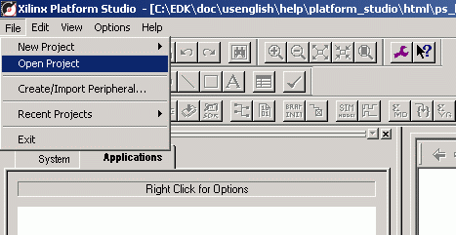

If you receive the following error message, the most likely problem is that the peripheral repository directory is incorrect for you installation.

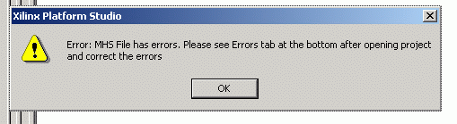

To set or correct the peripheral repository directory settings, select the “Options” pull down, and then select the “Project Options” button.
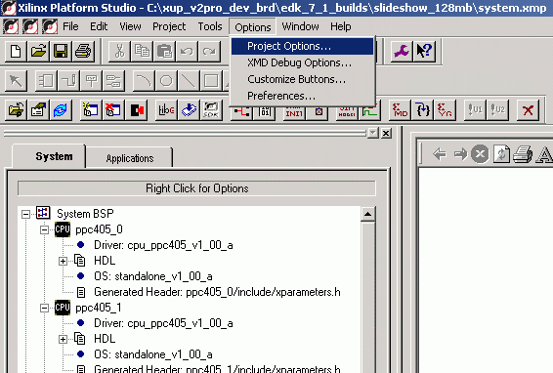

When you get the following menu, browse the peripheral repository directory or copy the directory path to the location of the /lib of the XUP VirtexII Pro Development board support libraries. The subdirectories contain the processor peripheral CORES and drivers used in this and several other reference design as well as the base system builder.
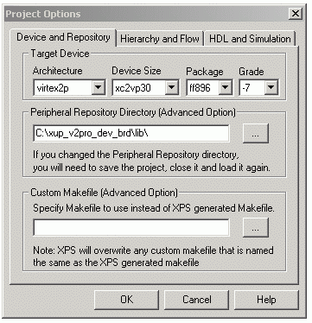
Then from the file menu select “project save” then from the file menu select “project close”. Then re-open the system.xmp project. When the project re-opens you should not get an error.

If you still receive the error message you may have an error in the in the .mhs file.

