Term Project
Wes Hendley, Jeff Morrison, James Faske

Introduction
The goal of this project was to take input from a keyboard through a PS2 port to the Xilinx VIRTEX-II PRO board, and then send output through a VGA port to a monitor. This involved using Xilinx Platform Studio (XPS), adding existing intellectual property (IP) to a project, and some coding in C. Similar skills were used in previous labs. Upon successful completion of this project, the user was able to type on a keyboard connected to the board and have the input echoed to the monitor as well as re-displayed on the RS232 console.

Equipment
Xilinx VIRTEX-II PRO board
XPS software
PS2 keyboard
VGA monitor
Procedure
To begin we found two existing XPS projects from the Xilinx website. One of these displayed a bitmap image to the VGA adapter, and the other received keyboard input from the ps2 adapter and displayed it at the RS232 console. The objective at this point would be to combine the two projects' hardware layout and software code to receive keyboard input and output it to the monitor through the VGA adapter.
We began with the pre-existing VGA project by adding hardware IPs just as they existed within the pre-existing ps2 project. These three IPs consisted of 2 objects to operate the ps2 interface (the ps2 adapter and the ps2 ports), as well as a more versatile RS232 interface (which we used for debugging keyboard input before we were able to get VGA output working).
At first we had to run through all the various hardware ports for these 3 new IPs and verify that they were connected into the hardware system properly. Once we had done that, we found that we had to change the clock speed that our RS232 IP operated at. At this point, we were able to receive working input from the keyboard to the RS232 console.
From here we examined the bitmap code from the pre-existing VGA project closely. We found that it was outputting to the VGA by means of a bitmap array in memory. This meant that any characters would have to be constructed pixel by pixel.
Fortunately we were able to find an existing library that converts a given character to its representative bitmap array, then writes this bitmap array to a framebuffer in memory at a given (x,y) coordinate. This meant that we just needed to convert the scancodes from the keyboard to their corresponding character and feed this character to this library function.

Using this library function, we were able to output a character to the VGA monitor. To emulate typing on a line, we tested spacing between characters on a line until it looked right on the VGA monitor. Finally we added C code to wrap character typing once it reached the edge of the screen, allow for use of the backspace key, and have the 'Enter' key start a new line of text.
§
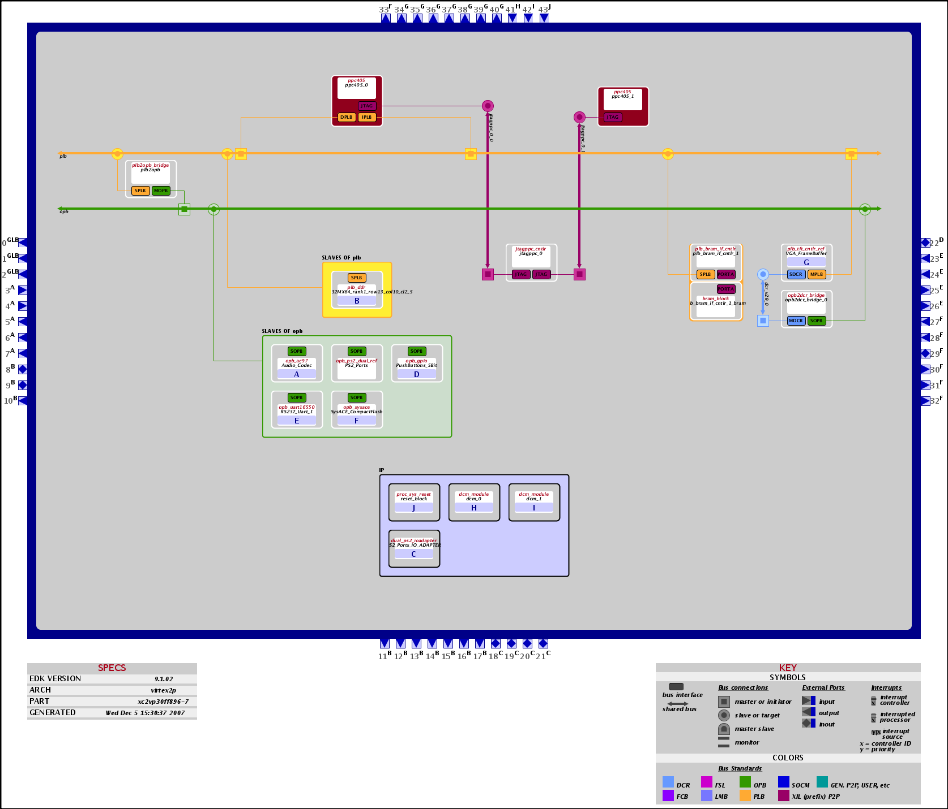 Our final, combined hardware layout

Results
The monitor would display a blank screen upon uploading of the project to the board. When the user typed characters on the keyboard connected to the board, the corresponding character would be output to the display. When the text reached the right side of the screen, it would wrap around to the next line. Additionally, the typed characters would be displayed on the console, as shown below: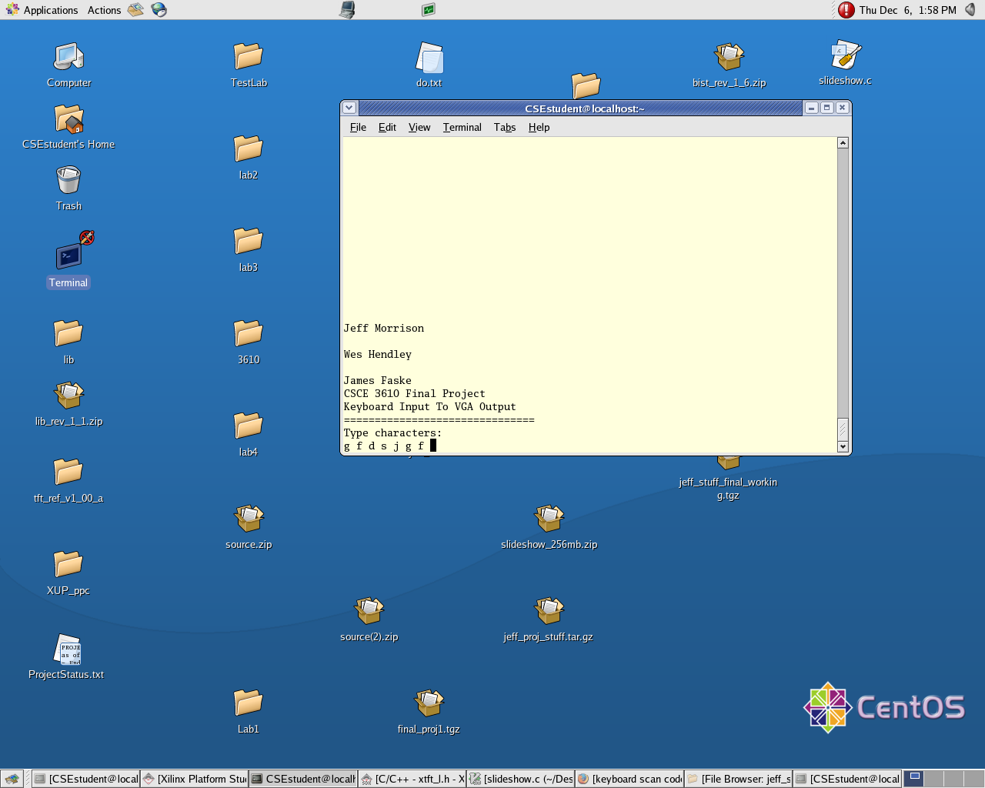
Figure 1Working keyboard input through RS232

Conclusion
The Xilinx software can be used to program the VIRTEX-II PRO board to accomplish a wide variety of goals, including taking input from a PS2 port, giving output to a VGA port, and providing for communication between the PS2 and VGA ports. These were the objectives of the project and all of them were met. This was made possible using existing IP downloaded from the Xilinx website, adding it to a project, and modifying it.

