Lab 4
VHDL Gates

Jeff Morrison
CSCE 3730
11/11/08
Description
The purpose of this project was to design the fundamental logic gates and components (using VHDL modules) that will be required to create the subcomponents of our 4bit ALU semester project.

Analysis
Each of these gates and components where fairly simple to design with minimal amounts of VHDL code per module. However, since they will be used repetitively in the overall ALU design, it is useful to have them ready to go.

Component Test-bench Waveforms

AND gate
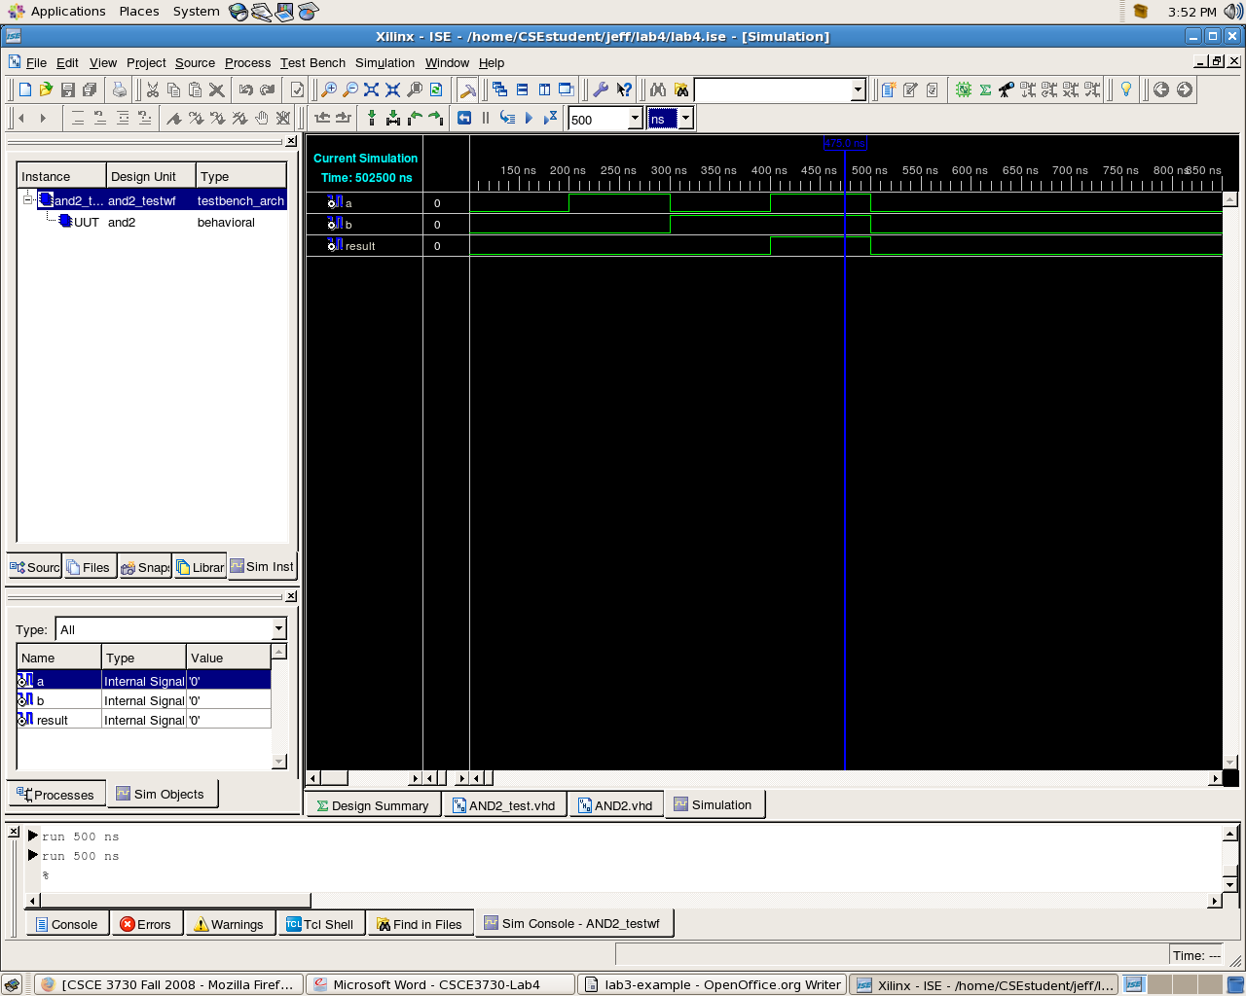
OR gate
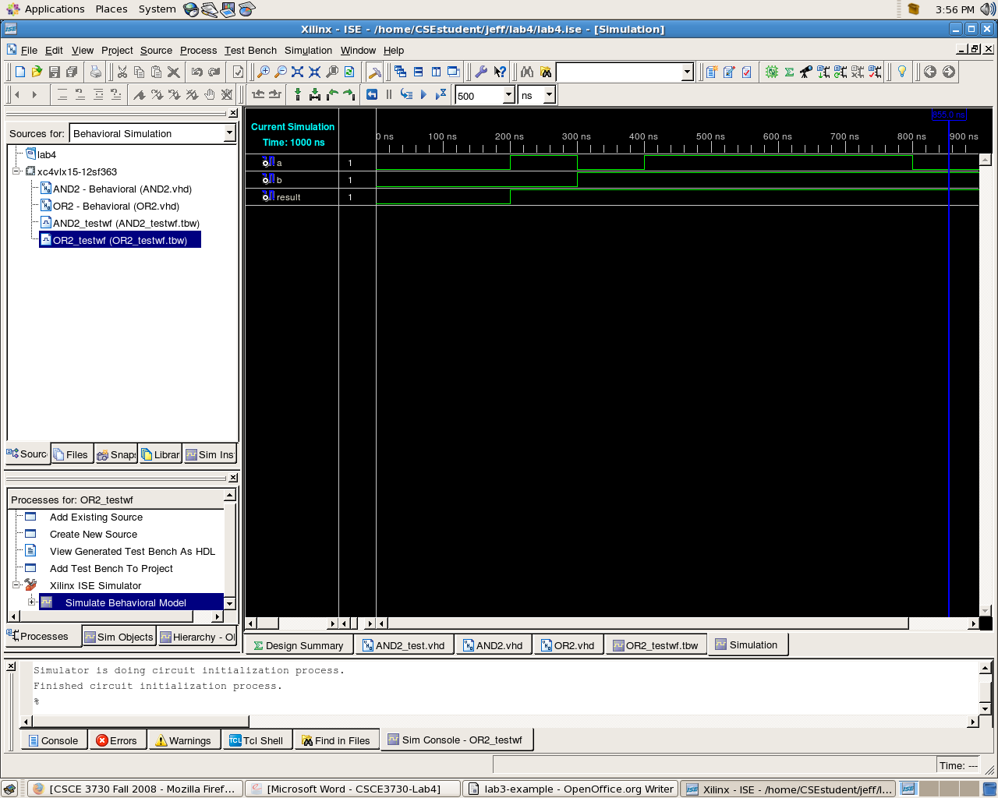
NOT gate
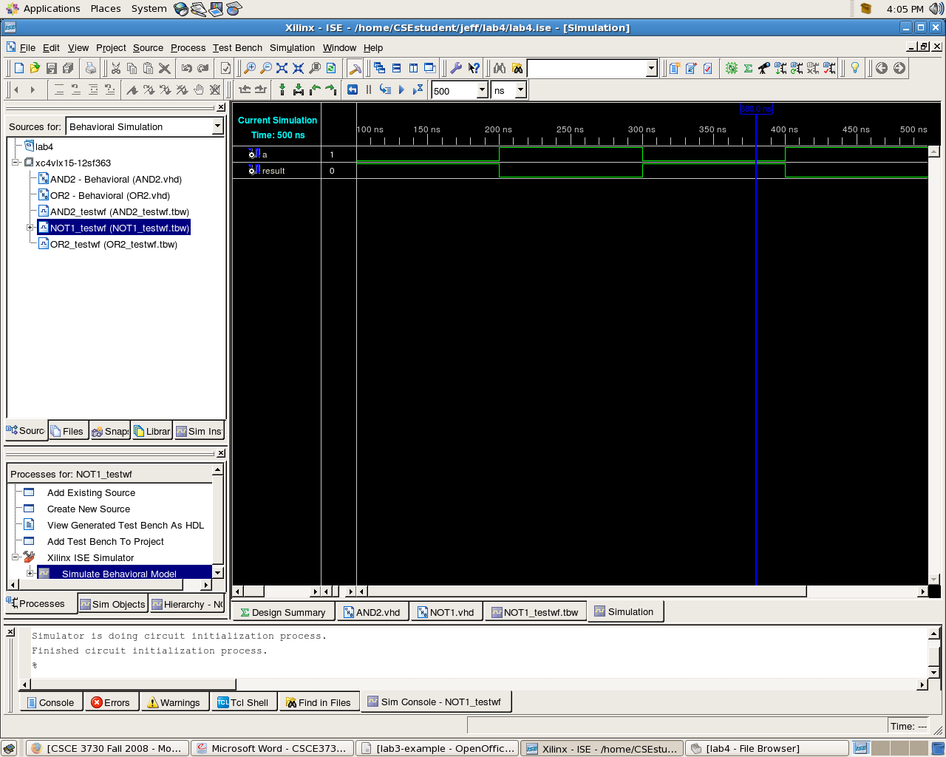
Adder component
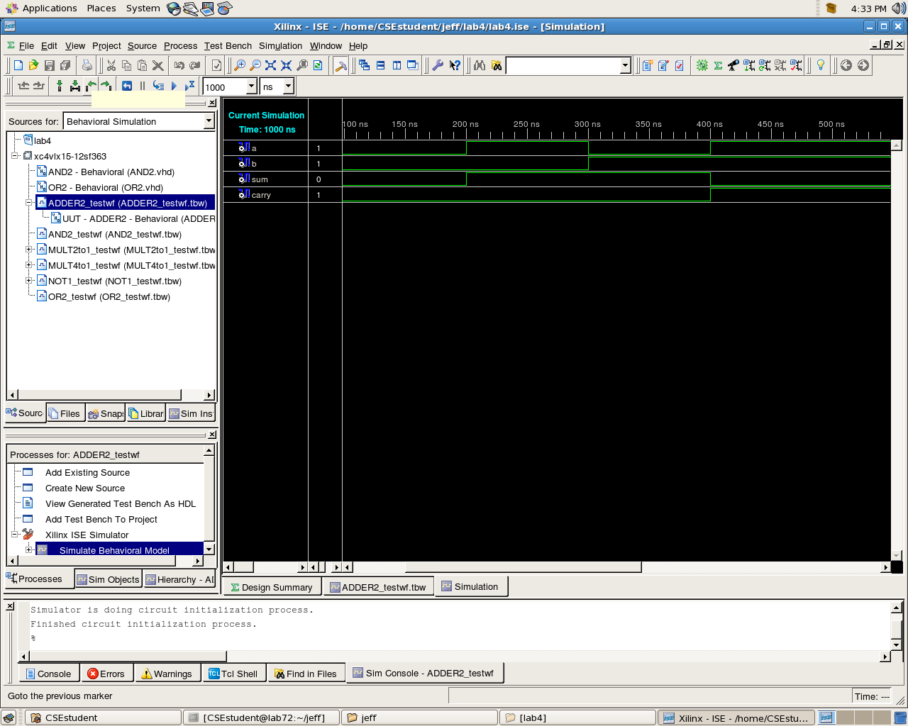
2 to 1 Multiplexer component
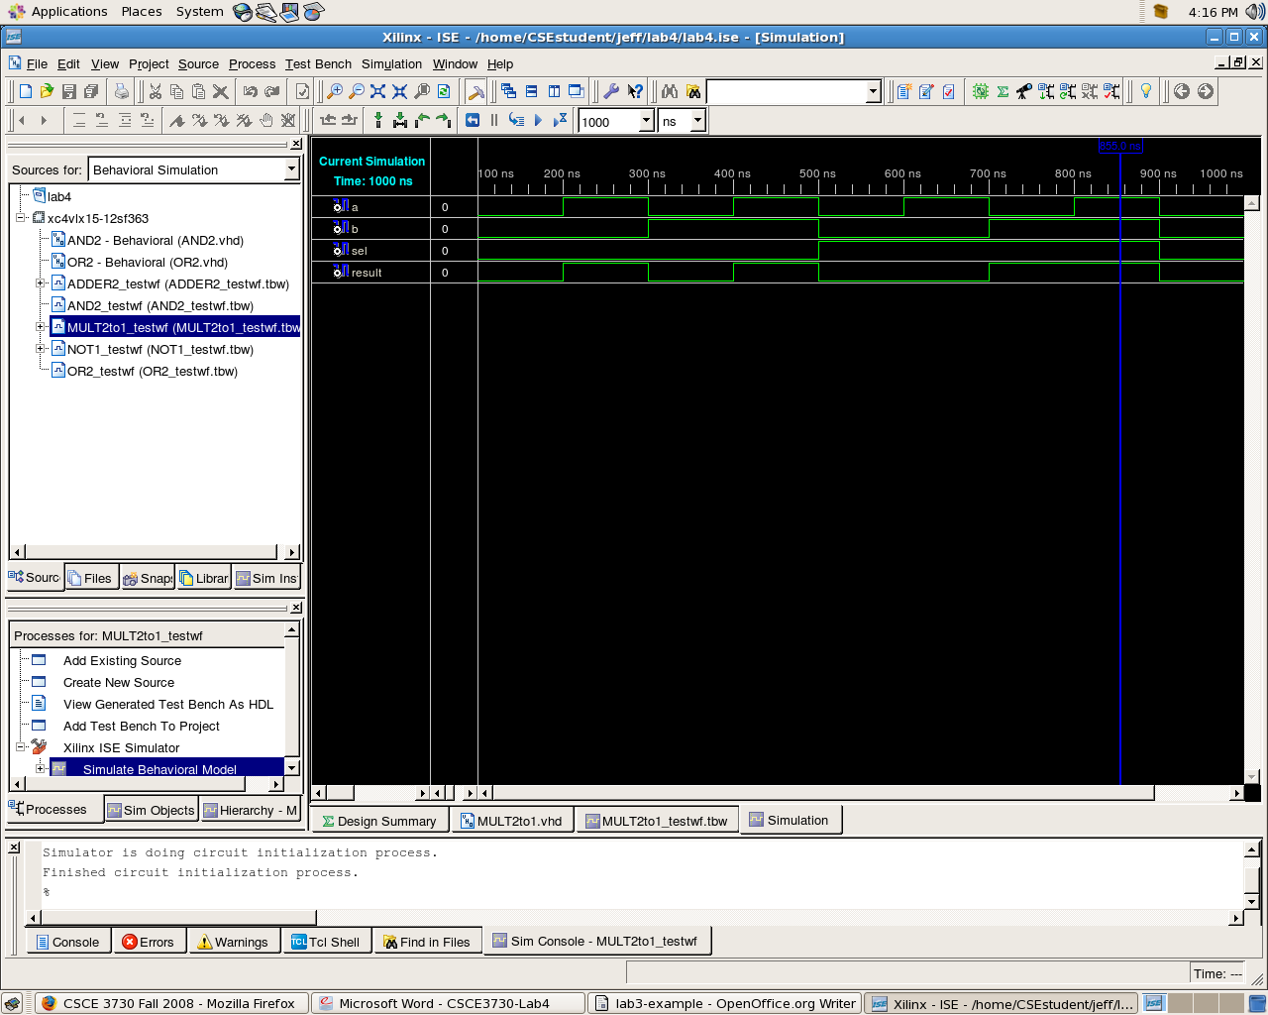
4 to 1 Multiplexer Component


