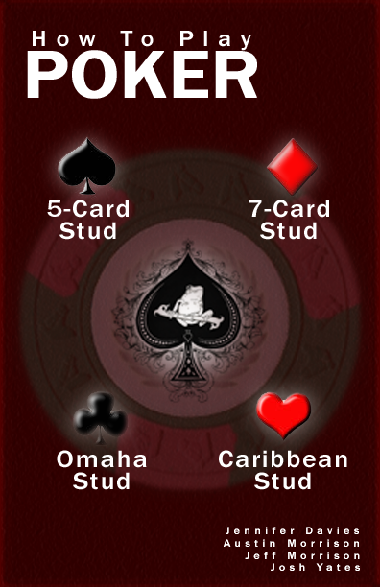

Table of Contents

Introduction 4
Terminology 5
Basics of Poker 8
Materials 8
Hand Ranks 8
Dealing/The Dealer 9
Betting 9
Draw and Stud Poker 10
5 Card Stud 11
7 Card Stud 12
Omaha Stud 13
Caribbean Stud 15
Conclusion 16
Glossary 17
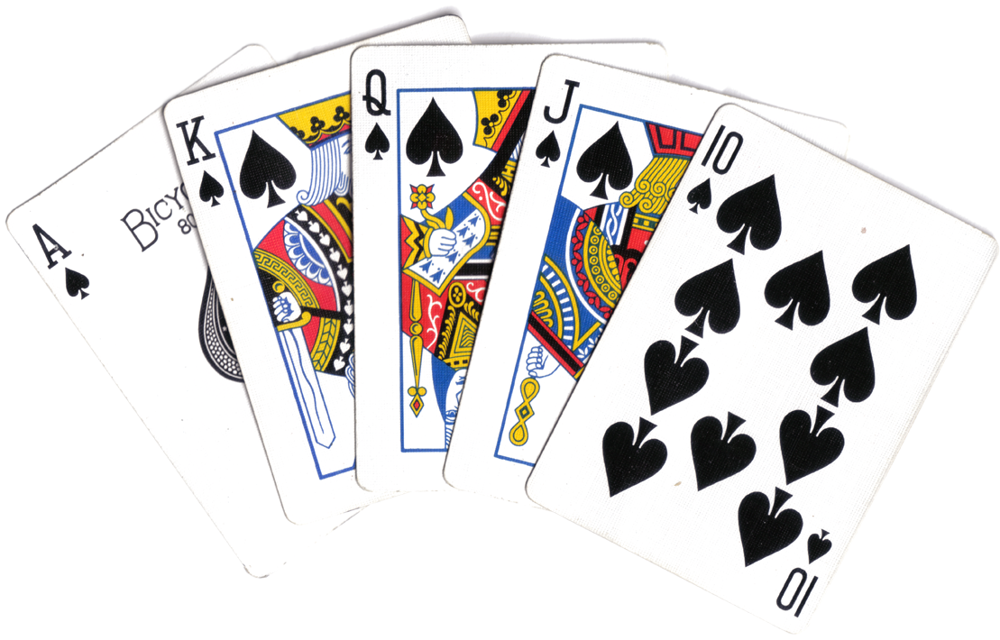

Introduction

The following teach the reader how poker works and how to play four select poker games including 5 Card Stud, 7 Card Stud, Omaha Stud, and Caribbean Stud. These games require one deck of cards, poker chips or some form of betting material, and a group of two or more people.

Try not to bend the cards when handling them and keep food, drinks, and any other substance that might stain or damage the cards or betting material away from your poker equipment.

Handling the cards in certain ways could result in paper cuts. Throwing the cards at other players could result in eye damage.

This manual explains the basic terminology and overall basic play of poker. An alphabetized glossary is located in the back for reference to specific term definitions.
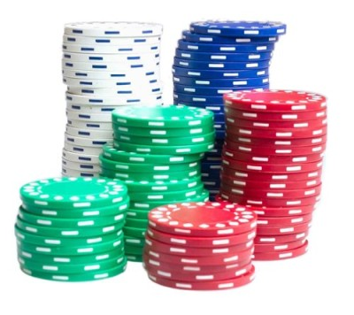

Terminology

Before we begin learning poker, you must become familiar with several terms used throughout this manual.

Deck | A full set of 52 cards (or 54 of the set includes 2 jokers)
Cut | The process of taking a large chunk of cards (usually about half the deck) from the top of the deck, and placing them under the remaining cards to eliminate any cheating.
Dealer | The person in the game who is in charge of the deck. The dealer must be sure everyone gets the cards they need to play the game during the game. Generally the dealer is also another player of the game, but does not have to be.
Deal | Refers to the process of giving out cards to individual players. This is done by the dealer at the beginning of the game, but can also occur at certain points during the game
Burn | An anti-cheating method the dealer makes before dealing a public card. The dealer takes the top card, discards it, and uses the next card at the top of the stack. This is done so that no advantage is given to any player who may have seen the top card of the deck before the rest of the players can.
Hold | A player holds a card when it has been dealt to him/her by the dealer.
Hand | Refers to a player's best grouping of cards that they are holding. There are predefined 'hands' in poker that will be explained in detail in the next section.
Wild Card | A wild card is a card, determined before the game starts, that can act as any other card to create a player's hand. Wild cards are not used often.
Round | Refers to the time from when the cards are dealt to when one or more players win just before the cards are dealt again.
Limit | A maximum bet any one player may bet per round.
Chip | A small circular object that represents the amount of money that is written on it. Before the game, a player may buy a chip for the amount written on it, and at the end of the game, the player may sell the chip back for the amount written on it. The general idea is to sell back more chips than you bought.
The Pot | Refers to all the chips all the players have bet so far in the round. If a single player wins the round, they will get to 'take the pot' (take all of the chips within the pot for them self)
Ante | Money (chips) placed into the pot before the round begins. This ensures money flow within the game.
Blind | A bet that is made without looking at your cards, but is included in a player's next bet (which is made after seeing the cards).
Ante Square | The location in front of each player where they place their ante.
Betting Square | The location in front of each player where they place their game bets.
Check | When it is a player's turn to bet, if no one before them has made any bets, the player may choose to 'check' or send the option to bet to the next player without actually placing any bet themselves.
Call | When it is a player's turn to bet, if a bet has been made before their turn, the player may choose to 'call', or place a bet equal to the biggest bet of any of the previous players.
Raise | When it is a player's turn to bet, if a bet has been made before their turn, the player may choose to 'raise', or place a bet bigger than any of the bets that were placed before them. This means that, in order to stay in the round, all the other players must either call or raise this player's new biggest bet.
Fold | When it is a player's turn to bet, if the player chooses to leave the round, they 'fold' by discarding the cards they are holding, leaving any chips they might have already bet in the pot, and waiting until the next round to play again.
Discard Pile | A pile of discarded cards. This can refer to the pile of 'burned' cards or a pile of cards from players who have folded.
Muck | At the end of the round the remaining players reveal their cards one at a time. If a player sees that a hand revealed that will beat their hand, the player may 'muck', or put their cards facedown on the table and admit defeat without showing their cards to any other players.
Push | The act of moving chips (a dealer will 'push' the pot to the winning player at the end of a round). If a player is said to 'push' this means he puts chips into the pot.
Rank | The priority of one card over another. The hand rank in poker is explained in the next section. The card rank in poker is as follows:  (starting with the lowest rank)
Suit | Each rank in a deck of 52 cards has four suits. In poker, no particular suit has priority over another. Ranks include Spades (♠), Diamonds (♦), Clubs (♣), and Hearts (♥).

Basics of Poker

Materials
- 2-10 players
- 52 card deck
- Poker chip set

Hand Ranks
- Royal Flush
Ace-King-Queen-Jack-10 each of the same suit.
(i.e. A♦-K♦-Q♦-J♦-10♦)
- Straight Flush
5 cards of the same suit and in sequence.
(i.e. 5♣-6♣-7♣-8♣-9♣)
- Four of a Kind
4 cards of the same rank.
(i.e. 5♠-5♦-5♥-5♣, Q♣-Q♠-Q♥-Q♦)
- Full House
3 of a kind and a pair, regardless of their rank.
(i.e. J♦-J♣-J♠-4♥-4♦, 8♠-8♥-8♦-2♥-2♠)
- Flush
A hand with any 5 cards of the same suit.
(i.e. 5♣-2♣-J♣-Q♣-7♣)
- Straight
5 cards in sequence of rank but not of same suit.
(i.e. 4♣-5♥-6♣-7♣-8♦)
- 3 of a Kind
3 cards of the same rank regardless of suit.
Any additional cards being held do not contribute to the requirements for a 3 of a Kind.
(i.e. 5♦-5♣-5♥-9♠-4♦, Q♣-Q♠-Q♥-4♥-A♠)
- 2 Pair
2 cards of one rank and 2 cards of another rank, all regardless of suit.
The cards being held not included in the 2 Pair do not matter.
(i.e. 5♥-5♠-7♣-7♠)
- 1 Pair
2 cards of one rank regardless of suit.
The cards being held not included in the 1 Pair do not matter.
(i.e. 5♦-7♦-8♠-9♥-9♠)
- High Card
Highest ranking card in a player’s hand. This is useful if two players have equally ranking hands

Dealing/The Dealer
In poker, the dealer deals starting with the player to his/her left. The dealer deals 1 card at a time in a clockwise rotation. All game play goes in clockwise rotation starting left of the dealer.

Betting
The player to the left of the dealer opens with an initial bet. The next player can call, raise, or fold. This continues until the bet reaches the set limit, until every player has either folded, or until every player has called.

Draw and Stud Poker

The draw variation of a poker game allows a player to replace unwanted cards for new cards from the dealer.
The stud variation of a poker game requires a deal of a number of cards (depending on the game) face down and face up. Generally, a player does not discard any of his/her dealt cards during a stud poker game.
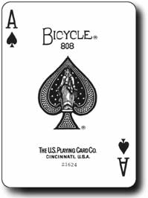

5 Card Stud

In 5 Card Stud, the dealer begins by dealing every player a card face down, called the hole card. The dealer then deals each player one card facing up. Players may look at their hole card but do not show it to the other players.

Now the first round of betting takes place. Betting starts with the player with the highest ranking card dealt face up. If a tie occurs between ranks of two players’ face up cards, the player closest to the left of the dealer in this tie begins the betting. This first betting player is called the starting better. As each player bets, they must call, raise, or fold. If they fold, they are out of the game.

After all players have called, checked, or folded, the dealer deals each player another face up card. The players bet again starting with the starting better.

This deal/bet combination happens two more times, so that each player will a hole card and 4 face-up cards. When each player has these 5 cards total and has placed their final bet, the players begin showing the cards they are holding starting with the player who has the best hand of face up cards.

The player with the best overall hand wins the pot and another round begins.

7 Card Stud

The object of 7 Card Stud, as with most other poker variations, is to finish with the best hand and win the pot.

Before receiving their cards from the dealer, each player must place an ante on the table. Next the dealer deals the Third Street, which consists of two hole cards (face down cards) and one door card (face up card). The player with the lowest door card, known as the starting better, bets first. The player to the left of the starting better bets next and so on.

After the betting round (each player has called, folded, or raised) the 4th Street is dealt. 4th Street is the fourth card dealt in the referred to as the 4th Street Betting Round

Next the 5th Street is dealt as a door card, which is the fifth card dealt to each of the players. This deal is followed by the 5th Street Betting Round.

After the 5th Street betting round ends, deal the 6th Street as another door card. 6th Street is the sixth card dealt to each of the players. This deal is followed by the 6th Street Betting Round.

Finally, deal The River Card/7th Street. 7th Street is the final card dealt out to each of the players. Unlike the 4th, 5th, and 6th streets, it is dealt as a hole card (a face down card). A final round of betting takes place.

If by the end of the final round of betting, two or more players are still in the game, they each turn over the best possible hand they can make out of their 7 cards. The highest hand wins the pot. If only one player remains in the game by the end of the last betting round, he/she wins the entire pot.

Omaha Stud

In Omaha Stud, each player has a set of their own cards and there are community cards that every player uses. Omaha Stud has two different versions: high only or hi/lo split. The high only version has only one winner, the player with the highest hand. If a tie occurs split the pot. In the hi/lo version, two players can win the pot: the one with the best highest hand and the one with the best lowest hand. The best lowest hand is ace, two, three, four and five. Most Omaha stud games use structured betting. The first two bets are the set structure amount. During the last two rounds of betting, double the structured bet. A game of Omaha stud contains two blinds: a small blind and a big blind. The player left of the dealer bets a small blind, which is half of the structured bet. The big blind player sits to the left of the small blind and bets the full structured bet amount. The blind positions rotate with the dealer in each successive round of play.

To start the game, the two blind players place their bets, no other players bet. Next, the dealer gives every player four cards face down known as the pocket cards. The player to the left of the big blind starts the first round of betting by either calling, raising, or folding. The betting continues around the table until everyone raises or calls. At the end of the first round of betting, the big blind has the option to raise by doubling the structured bet amount. The big blind can only do this during the first round of betting.

After the first round of betting, the dealer burns the top card on the deck. Then the dealer puts three cards, face up, on the table forming the start of the set of community cards. This move by the dealer is the flop. A second round of betting takes place starting with the player to the left of the dealer.

The dealer burns another card then adds a fourth card to the community cards. The fourth card is the turn. The next round of betting stars with the player to the left of the dealer. The amount of this bet is at least double the structured bet. The players, during this third round of betting, try to make the best hi or lo hand (depending on the version played) out of two cards in their pocket and three community cards. Any player may organize a hand using any combination of the cards they are holding as well as any combination of the community cards.

The dealer burns another card and places a fifth card from the top of the deck, face up, on the table alongside the other community cards. The fifth card is the river. The player to the left of the dealer starts last round of betting with a minimum amount of double the structured bet.

The player who makes the last bet must show their cards. The player to the left of this person shows his cards (or mucks his/her cards) next, and so on around the table clockwise. If playing Omaha hi/lo split, split the pot between the player with the best high hand and the player with the best low hand. If playing Omaha high, give the whole pot to the player with the best high hand. The next round starts with the dealer and blind positions moving to the left by one position.
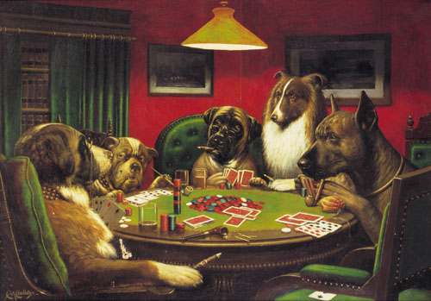

Caribbean Stud

Caribbean Stud involves as many players as you want. All players play against the dealer. The objective of the game is to beat the dealer's hand by combining the best possible 5 cards.

Each player has two betting spots in front of them: an ante square and a betting square. Before the game starts, each player must put in an ante.

The dealer deals 5 cards to each player face down. He also deals him self 4 cards face down and 1 card face up so that every player can see it.

The players can now either, bet or fold. If a player chooses to fold, he forfeits the round and looses the amount he put into his ante square. If a player chooses to bet, they must place a bet that is twice the amount of their antes into the betting square.

After all the players have bet or folded, the dealer flips over his four face-down cards. If the dealer loses (he/she does not have an Ace and a King) then all of the players push their bets and another betting round begins. Otherwise, if your hand beats the dealer’s hand, then the dealer must pay you whatever you bet plus your ante. If the dealer’s hand wins (he/ she holds an Ace and a King) then the dealer takes your bet and your ante.

Some casinos pay out differently according to house odds.

Conclusion

It should now be clear how to play 5 Card Stud, 7 Card Stud, Omaha Stud, and Caribbean Stud. These instructions can be helpful for anyone that wishes to learn any of these types of poker.
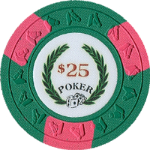

Glossary

1 Pair – A hand consisting of 2 cards of one rank regardless of suit.

2 Pair – A hand consisting of 2 cards of one rank plus 2 cards of another rank all regardless of suit. The fifth card may serve as a 'kicker' in the case where two players have an equal 2-pair. The player with the highest ranking kicker wins.

3 of a Kind – A hand consisting of 3 cards of the same rank regardless of suit. Any additional cards do not contribute to the requirements of a 3 of a Kind.

3rd Street – The first three cards dealt to each of the players in a 7 Card Stud game.

^{4th} Street – The fourth card dealt to each of the players in a 7 Card Stud game.

^{5th} Street – The fifth card dealt to each of the players in a 7 Card Stud game.

Ante – Money (chips) placed into the pot before the round begins. This ensures money flow within the game.

Ante Square – The location in front of each player where they place their ante.

Betting Square – The location in front of each player where they place their game bets.

Blind – A bet that is made without looking at your cards, but is included in a player's next bet (which is made after seeing the cards).

Burn – An anti-cheating method the dealer makes before dealing a public card. The dealer takes the top card, discards it, and uses the next card at the top of the stack. This is done so that no advantage is given to any player who may have seen the top card of the deck before the rest of the players can.

Call – When it is a player's turn to bet, if a bet has been made before their turn, the player may choose to 'call', or place a bet equal to the biggest bet of any of the previous players.

Card Rank – The priority of one card over another.
(lowest rank in poker is 2, highest rank is Ace)

Check – When it is a player's turn to bet, if no one before them has made any bets, the player may choose to 'check' or send the option to bet to the next player without actually placing any bet themselves.

Chip – A small circular object that represents the amount of money that is written on it. Before the game, a player may buy a chip for the amount written on it, and at the end of the game, the player may sell the chip back for the amount written on it. The general idea is to sell back more chips than you bought.

Cut – The process of taking a large chunk of cards (usually about half the deck) from the top of the deck, and placing them under the remaining cards to eliminate any previous knowledge of the top card or the bottom card.

Deal – Refers to the process of giving out cards to individual players. This is done by the dealer at the beginning of the game, but can also occur at certain points during the game.

Dealer – The person in the game who is in charge of the deck. The dealer must be sure everyone gets the cards they need to play the game during the game. Generally the dealer is also another player of the game, but does not have to be.

Deck – A full set of 52 cards (or 54 of the set includes 2 jokers).

Discard Pile – A pile of discarded cards. This can refer to the pile of 'burned' cards, or a pile of cards from players who have folded.

Door Card – The face up card(s) dealt to each player in a 5 Card or 7 Card Stud game.

Flush – Any hand with five cards each of the same suit. (regardless of rank or sequence)

Fold – When it is a player's turn to bet, if the player chooses to leave the round, they 'fold' by discarding the cards they are holding, leaving any chips they might have already bet in the pot, and waiting until the next round to play again.

Four of a Kind – A hand of four cards of the same rank.

Full House – A hand consisting of a 3 of a Kind and a 1 Pair together.

Hand – Refers to a player's best grouping of cards that they are holding. There are predefined 'hands' in poker that will be explained in detail in the next section.

Hand Rank – The priority of one hand of cards over another.

Hold – A player holds a card when it has been dealt to him/her by the dealer.

Hole Card – The face down card(s) dealt to each player in a 5 Card or 7 Card Stud game.

Limit – A maximum bet any one player may bet at a time. This limit generally applies to each time a player is asked to bet, therefore the limit does not describe the maximum amount a player may bet in a single round.

Muck – At the end of the round the remaining players reveal their cards one at a time. If a player sees that a hand revealed that will beat their hand, the player may 'muck', or put their cards facedown on the table and admit defeat without showing their cards to any other players.

Push – The act of moving chips (a dealer will 'push' the pot to the winning player at the end of a round). If a player is said to 'push' this means he gives the chips he has bet to the winner of the round.

Raise – When it is a player's turn to bet, if a bet has been made before their turn, the player may choose to 'raide', or place a bet bigger than any of the bets that were placed before them. This means that, in order to stay in the round, all the other players must either call or raise this player's new biggest bet.

Round – Refers to the time from when the cards are dealt to when one or more players win just before the cards are dealt again.

Royal Flush – The highest hand rank of an Ace-King-Queen-Jack-10 each of the same suit.
(see Hand Ranks on pg. 8)

Shuffle – Any process of randomly re-ordering the deck.

Starting Better – Player who makes the first bet in a round of betting.

Straight – A hand consisting of 5 cards in sequence of rank, but not all of the same suit.

Straight Flush – A hand of five cards of the same suit in ascending sequence.

Suit – Each rank in a deck of 52 cards has four suits. In poker, no particular suit has priority over another. Ranks include Spades (♠), Diamonds (♦), Clubs (♣), and Hearts (♥).

The Flop – The first three community cards dealt by the dealer in a game of Omaha or Texas Hold'Em.

The Pot – Refers to all the chips all the players have bet so far in the round. If a single player wins the round, they will get to 'take the pot' (take all of the chips within the pot for them self).

The River – The fifth community card dealt by the dealer in a game of Omaha or Texas Hold'Em. Also the last (7th) card dealt to each of the players in a game of 7 Card Stud.

The Turn – The fourth community card dealt by the dealer in a game of Omaha or Texas Hold'Em.

Wild Card – A wild card is a card, determined before the game starts, that can act as any other card to create a player's hand.

