About Sport Clubs

A sport club is an organization recognized by students and approved by the Director of Recreational Sports and the Sport Club committee. A sport club provides instructional, recreational, and competitive organization of sports activities for students. Organized activities for a club include practice sessions and competitions against similar groups from other institutions in the Texas area. Although these competitions are the emphasis of sport clubs, meetings and social functions are also held for members.

The Recreational Sports office provides encouragement, guidance, and supervision for the clubs as well as assistance in scheduling of facilities for club meetings, practices, and competitions. Additionally, the Recreational Sports office will provide partial funding for travel, competitions and equipment.

Starting a Sport Club
- Contact the Recreational Sports office for authorization assistance.
- Apply for registration as a student organization at the Student Activities office in the Union.
- Publicize the club on campus and hold a meeting for interested students to join the club.
- Designate officers and a student leader to represent the club
- The following is required and must be submitted to the Recreational Sports Office:
- Projected Budget  - Group Roster  - Properly completed liability waivers | - Schedule of proposed activities for the year  - Workout or practice schedule
- Sports clubs that are registered with the Student Activities office may then apply to the Assistant Director of Sport Clubs for authorization as a sport club.
- The student leader must appear before the sport club committee to support their authorization request.
- The Director of Recreational Sports, Assistant Director and the sport club committee will approve or disapprove a club’s authorization and budget.
Management of Sport Clubs

A club’s growth is determined by active student involvement. Involved students must plan their own schedule of activities. The student leader is the liaison with the Recreational Sports office. All information concerning sport club policies and procedures is directed through the student leader.

The Sport Club Committee

The sport club committee is a policy-making body for the sport club program. The sport club committee is composed of two faculty or staff member and three UNT students. The committee divides student service funds between approved clubs. The division of funds is based on factors such as membership, frequency of activity, and need.

Eligibility Requirements

- Club membership is open to enrolled UNT students of any skill level.
- Clubs may have additional criteria regulating the type of membership.
- A student cannot be a member of a representative team or group in a sport in which they have been a professional.
- A student may not participate in a sport in Intramurals if he/she is listed on a sport club’s roster for the same sport or a similar sport.
(More specific information on this and other sport club policies is available in the sport club manual)
Sport Club Policies

- The deadline for new clubs to apply for funding from the Recreational Sports office is mid-September for the fall semester and early February for the spring semester.
- There is a maximum funding allocation for the first semester for all new sport clubs.
- A one-way, 350 mile limitation on travel has been set to encourage local travel. For travel over 350 miles, the sport club committee must approve.
- Clubs are limited to certain allotments of funding for their travel and competitions. Club members may finance a portion of their participation expenses from personal savings.
- Members of any club within the sport club program must be registered for at least one hour of course work with the University of North Texas.
- Fund raising projects are limited to one project per semester. Fund raising projects must be approved at least two weeks prior to the start of the project by the club’s faculty sponsor, the Director of Recreational Sports, and the Assistant Director of Sport Clubs.
- Any policy regarding the internal operation of a club may be implemented as long as the Recreational Sports office and the majority of members within that club agree.

- Clubs will not be funded for tournaments which award scholarships to an individual unless the award.
Recreational Sports
Student Recreation Center, Room 103
940-565-2275

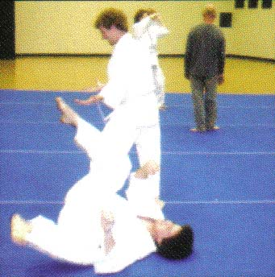  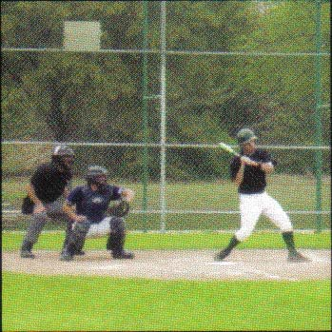  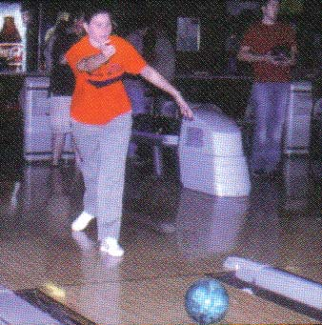    Get Involved  With  Sport Clubs! | Sport Clubs
AIKIDO
The aikido club is a martial arts organization that works out two to three times per week. The club encourages student to attend local aikido seminars. Aikido is open to all UNT students. Classes are taught by certified black belt instructors

BASEBALL
The baseball club has a very competitive schedule and competes in the Gulf Coast Conference of the NCBA. New players are welcome.

BILLIARDS
The billiards club promotes the sport and fun of 8-ball, 9-ball, snooker, and corom billiards games. The club competes against other universities and clubs at area and regional levels. Weekly meetings and practice times are held in the Syndicate Games Room in the Union. No prior experience is required. Join as a beginner or advanced player and become part of the world-wide sport of billiards!

BOWLING
Like to bowl? Then come and join the nationally-ranked UNT bowling club. If you are competitive, you can travel with the team to tournaments and bowl against other schools in the region and country, or you can just show up to practice and have some fun. All levels welcome to come out and practice.

FENCING  The fencing club competes in many of the local and regional tournaments in the North Texas Division. The club practices two times a week and welcomes anyone interested in joining the club.  GO  Go is one of the oldest board games still currently played. No experience is necessary to join.  ICE HOCKEY  The ice hockey club is a member of the American Collegiate Hockey Association Division III and the Hockey Southwest League (CHSW). This is a competitive club that welcomes new members.  IN-LINE HOCKEY  The in-line hockey club holds practices once per week in Denton and competes in the Southwest Collegiate Hockey League.  MEN’S LACROSSE  The Men’s Lacrosse club practices two times per week and competes in the Southwest Lacrosse Conference. No experience necessary to join.  MEN’S RUGBY  The rugby club practices two times a week and competes against other colleges, universities, and sports clubs as a member of the Texas Rugby Union. | MEN’S SOCCER  The men’s soccer club is open to all skill levels and competes in the Texas Collegiate Soccer League.  MEN’S ULTIMATE DISC  The men’s ultimate disc club is open to those interested in competing in tournaments as well as recreational play. The club competes against other colleges, universities, and sport clubs and practices two times per week. All skill levels are welcome.  MULTI-SPORT  The multi-sport club promotes the sports of triathlons, biathlons, and adventure races. Practices are held several times per week and the club participates in various competitions in the area.  SAILING  The sailing club is open to all students regardless of sailing experience. The club sails at the Dallas Corinthian Yacht Club on Lake Lewisville.  WOMEN’S LACROSSE  The women’s lacrosse club is open to all skill levels and competes in the Texas Women’s Lacrosse League.  WOMEN’S ULTIMATE DISC  This club is open to all skill levels and competes against other colleges, universities, and sport clubs.      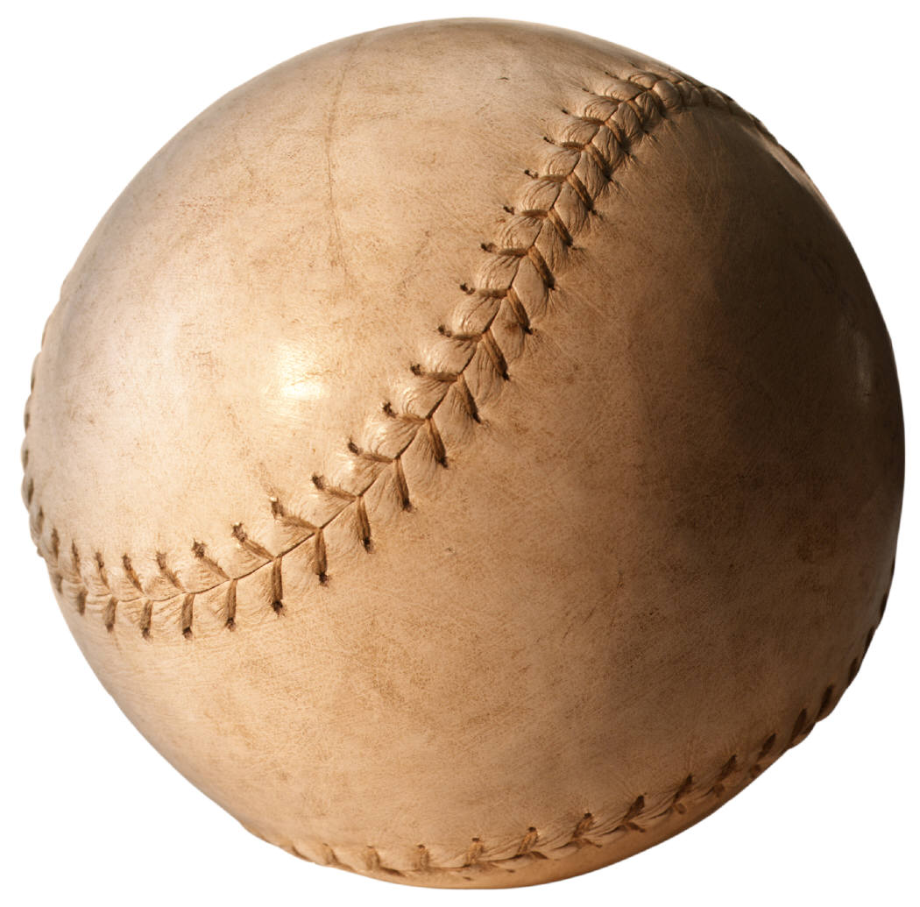  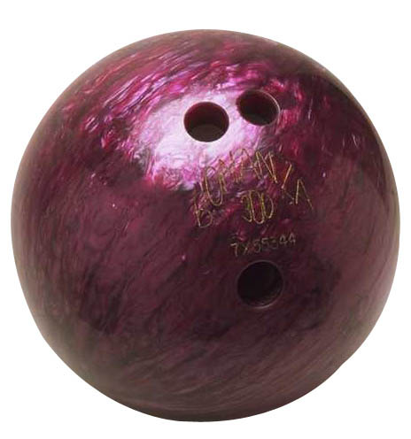    Sport  Clubs  Recreational Sports  Student Recreation Center  Room 103  940 – 565 – 2275  www.unt.edu/recsports

